**Thomas and Friends  
(Games and Math puzzles)**

[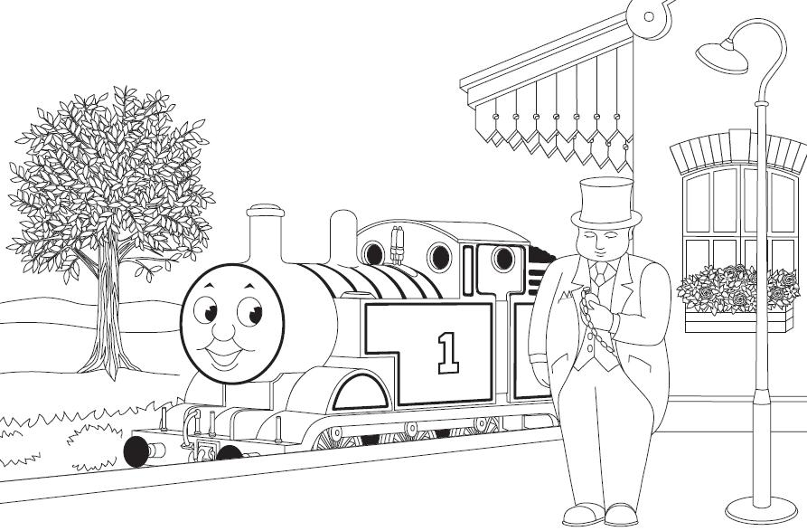](http://rds.yahoo.com/_ylt=A0PDoX3dlCxPN30Ac_SjzbkF;_ylu=X3oDMTBpcGszamw0BHNlYwNmcC1pbWcEc2xrA2ltZw--/SIG=11q5kd2gp/EXP=1328350557/**http:/thomas-the-engine.blogspot.com/)

**Made by: Ms. Morean**

**For: Giovanni**



How many engines are at Tidmouth Sheds?

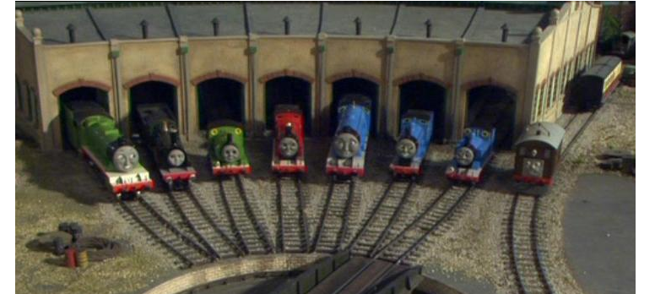

Circle the correct number.

**1 2 3 4 5 6 7 8**

Circle the engine that has the number ten (10).

[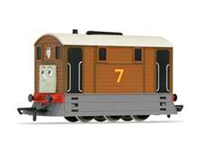](http://images.search.yahoo.com/images/view;_ylt=A0PDoX.kkyxP9GAAKP2JzbkF;_ylu=X3oDMTA3cnMybzJvBHNsawNpbWc-?back=http://images.search.yahoo.com/search/images?p=toby+tram+engine&n=30&ei=utf-8&y=Search&tab=organic&ri=71&w=334&h=260&imgurl=www.hornby.com/_assets/images/cache/shops/productdetailsmain/R9046.jpg&rurl=http://www.hornby.com/shop/locomotives/thomas-and-friends-locomotives/r9046-toby-the-tram-engine/&size=35.6+KB&name=Hornby+Model+Railways+-+Toby+the+Tram+Engine&p=toby+tram+engine&oid=89e272281e03b4a23d64f66771a03591&fr2=&fr=&tt=Hornby+Model+Railways+-+Toby+the+Tram+Engine&b=61&ni=60&no=71&tab=organic&ts=&sigr=131gk2ne3&sigb=138gaocu2&sigi=126p3emsd&.crumb=RfDs76VF5T1)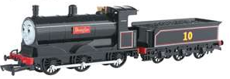[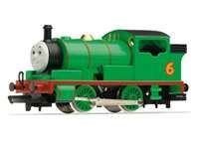](http://images.search.yahoo.com/images/view;_ylt=A0PDoX9PkyxPOWEASFiJzbkF;_ylu=X3oDMTA3cnMybzJvBHNsawNpbWc-?back=http://images.search.yahoo.com/search/images?p=percy+tank+engine&n=30&ei=utf-8&y=Search&tab=organic&ri=51&w=300&h=230&imgurl=www.wonderlandmodels.com/media/managed/large/r9686.jpg&rurl=http://www.wonderlandmodels.com/products/hornby-percy-british-stamp-collection/&size=19.1+KB&name=Percy+the+Saddle+Tank+Engine+Steam+Locomotive+British+Stamp+Collection+...&p=percy+tank+engine&oid=0795607769220ae128d625d46c9c8c6b&fr2=&fr=&tt=Percy+the+Saddle+Tank+Engine+Steam+Locomotive+British+Stamp+Collection+...&b=31&ni=60&no=51&tab=organic&ts=&sigr=12fqgnjvb&sigb=139g3o70i&sigi=11m7eh14v&.crumb=RfDs76VF5T1)

Help Thomas find his way to the circle.

[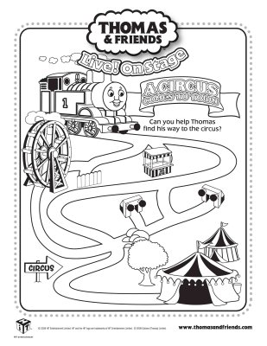](http://rds.yahoo.com/_ylt=A0PDoS02lixPwgcAaJWjzbkF;_ylu=X3oDMTBpcGszamw0BHNlYwNmcC1pbWcEc2xrA2ltZw--/SIG=12qee8ak8/EXP=1328350902/**http:/constellationav.com/zuyq/el-thomas-and-friends-coloring-sheets/)

  
Let’s count the numbers together.

1[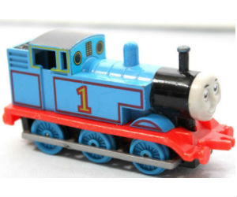](http://rds.yahoo.com/_ylt=A0PDoS6puixPJ24AnhijzbkF;_ylu=X3oDMTBpcGszamw0BHNlYwNmcC1pbWcEc2xrA2ltZw--/SIG=12ebiv023/EXP=1328360233/**http:/thomasthetrain.net/index.php/pages/ertl-thomas.html) 2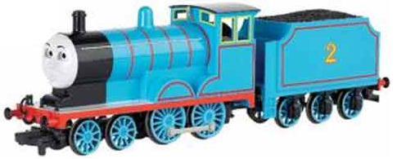

3 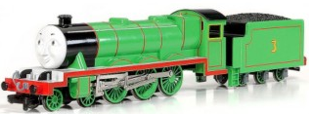 4[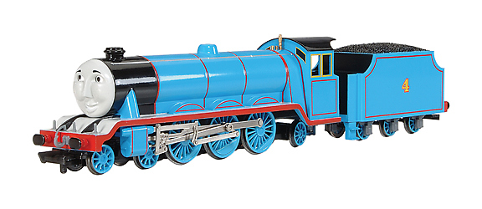](http://images.search.yahoo.com/r/_ylt=A0PDoS4MKzNPfGAAqYqjzbkF;_ylu=X3oDMTBpcGszamw0BHNlYwNmcC1pbWcEc2xrA2ltZw--/SIG=13lpkb4l7/EXP=1328782220/**http:/shop.nmj.no/product_info.php?manufacturers_id=40&amp;products_id=2094&amp;osCsid=411)5 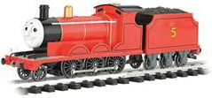 6 [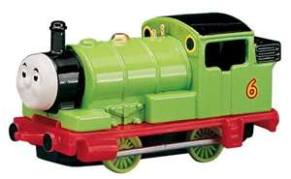](http://images.search.yahoo.com/images/view;_ylt=A0PDoX9iuyxPZHUA0gyJzbkF;_ylu=X3oDMTA3cnMybzJvBHNsawNpbWc-?back=http://images.search.yahoo.com/search/images?p=diecast+percy&n=30&ei=utf-8&y=Search+Images&tab=organic&ri=48&w=500&h=309&imgurl=ecx.images-amazon.com/images/I/417D22YD9PL.jpg&rurl=http://vehiclestoys.guidestobuy.com/&size=30.2+KB&name=Buy+Thomas+the+Tank+Engine+Shining+Time+Station+PERCY+diecast+train&p=diecast+percy&oid=a89cf4302dcd39231ef40e8805d99e40&fr2=&fr=&tt=Buy+Thomas+the+Tank+Engine+Shining+Time+Station+PERCY+diecast+train&b=31&ni=84&no=48&tab=organic&ts=&sigr=114g5kb5u&sigb=13cod4t0p&sigi=11ejlk23b&.crumb=RfDs76VF5T1) 7 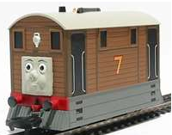 9 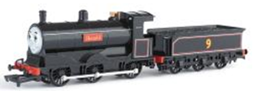  
8 [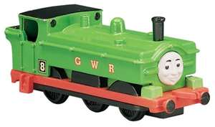](http://images.search.yahoo.com/images/view;_ylt=A0PDoS5euyxPdGUADtKJzbkF;_ylu=X3oDMTA3cnMybzJvBHNsawNpbWc-?back=http://images.search.yahoo.com/search/images?p=diecast+percy&n=30&ei=utf-8&y=Search+Images&tab=organic&ri=11&w=500&h=295&imgurl=ecx.images-amazon.com/images/I/41RGB19S3SL.jpg&rurl=http://vehiclestoys.guidestobuy.com/thomas-the-tank-engine-shining-time-station-percy-diecast-train&size=27.6+KB&name=...+Tank+Engine+Shining+Time+Station+PERCY+diecast+train+|+Vehicles+Toys&p=diecast+percy&oid=6c70e9d916bb622fa4c71ea70abf1ccb&fr2=&fr=&tt=...+Tank+Engine+Shining+Time+Station+PERCY+diecast+train+|+Vehicles+Toys&b=0&ni=84&no=11&tab=organic&ts=&sigr=133ged2nf&sigb=13cpqag2u&sigi=11ecb2s8i&.crumb=RfDs76VF5T1) 10 

11[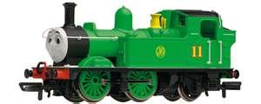](http://images.search.yahoo.com/images/view;_ylt=A0PDoX60LjNPYhAAsjGJzbkF;_ylu=X3oDMTBlMTQ4cGxyBHNlYwNzcgRzbGsDaW1n?back=http://images.search.yahoo.com/search/images?p=oliver+thomas+and+friends&n=30&ei=utf-8&y=Search+Images&tab=organic&ri=3&w=750&h=300&imgurl=www.modelr.co.uk/images/product/hornby-R9070.jpg&rurl=http://www.modelr.co.uk/products/hornby-r9070/oliver/&size=140.2+KB&name=listed+in+50+00+99+99+hornby+oo+thomas+friends&p=oliver+thomas+and+friends&oid=641c8e256a86a95b8f5b25409153f8cf&fr2=&fr=&tt=listed+in+50+00+99+99+hornby+oo+thomas+friends&b=0&ni=128&no=3&tab=organic&ts=&sigr=11lhkv5qp&sigb=13nrd7645&sigi=11gq1koc3&.crumb=U.CAUwVdo0G) 12 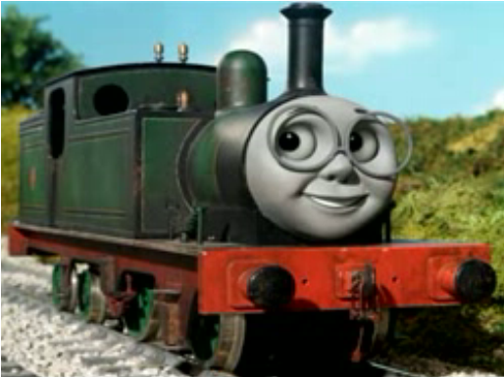

13 [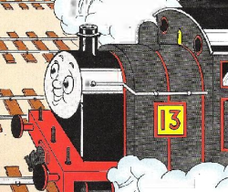](http://images.wikia.com/ttte/images/f/f5/Thirteen.png) 14 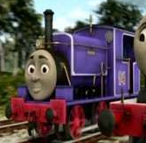 15 [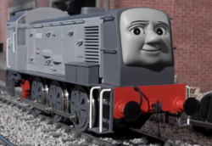](http://images.wikia.com/ttte/images/4/4a/Thomas'DayOff7.png) 16 [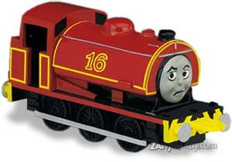](http://images.search.yahoo.com/images/view;_ylt=A0PDoTFRMzNPmUUA7U2JzbkF;_ylu=X3oDMTBlMTQ4cGxyBHNlYwNzcgRzbGsDaW1n?back=http://images.search.yahoo.com/search/images?p=sixteen+thomas+and+friends&n=30&ei=utf-8&y=Search&tab=organic&ri=0&w=500&h=350&imgurl=www.g-ratedstuff.com/thomas_pix/sixteen.jpg&rurl=http://www.g-ratedstuff.com/thomas_page.htm&size=22.2+KB&name=Sixteen&p=sixteen+thomas+and+friends&oid=52c19c0ed8a2f42b0ecb9cdd3d3f3c86&fr2=&fr=&tt=Sixteen&b=0&ni=128&no=0&tab=organic&ts=&sigr=11b9dgs73&sigb=13hu8nq2a&sigi=11b2j1vv6&.crumb=U.CAUwVdo0G)17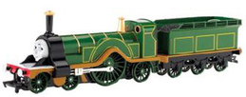 18 [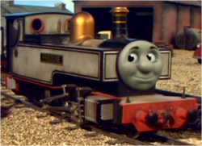](http://images.wikia.com/ttte/images/7/77/Freddie.png) 19 [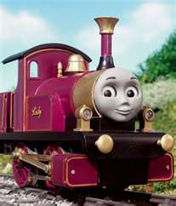](http://images.search.yahoo.com/images/view;_ylt=A0PDoTDUNjNP2TIAZ0KJzbkF;_ylu=X3oDMTBlMTQ4cGxyBHNlYwNzcgRzbGsDaW1n?back=http://images.search.yahoo.com/search/images?p=lady+thomas+and+friends&n=30&ei=utf-8&y=Search&tab=organic&ri=5&w=316&h=368&imgurl=images.wikia.com/ttte/images/2/24/Lady.jpg&rurl=http://ttte.wikia.com/wiki/Lady&size=31.3+KB&name=Lady+-+Thomas+the+Tank+Engine+Wikia&p=lady+thomas+and+friends&oid=a1ee9d9f8139048b8cf5edbcd163ba66&fr2=&fr=&tt=Lady+-+Thomas+the+Tank+Engine+Wikia&b=0&ni=96&no=5&tab=organic&ts=&sigr=10v80qeae&sigb=13es17ni6&sigi=11afiu0be&.crumb=U.CAUwVdo0G) 20 [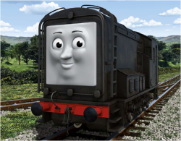](http://images.wikia.com/ttte/images/3/3f/DieselCGIpromo.png)



Connect the dots to finish the engines. Color.

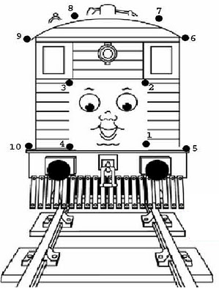   
 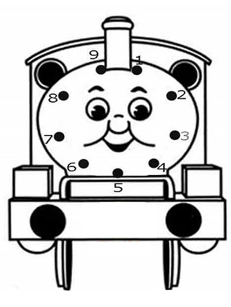

Cut out Thomas and friends pasting them into the correct color category.

YELLOW BLUE GREEN

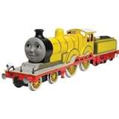 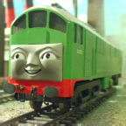 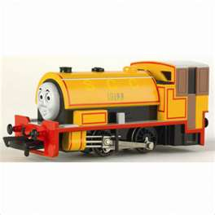

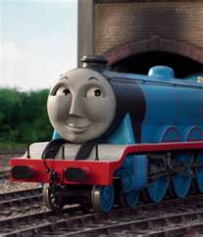 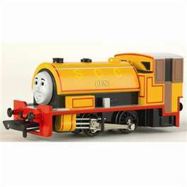 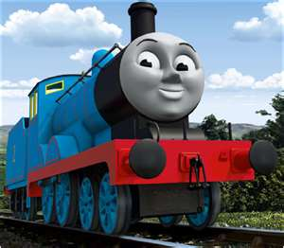

[](http://images.search.yahoo.com/images/view;_ylt=A0PDoS5WQC9PyAgAHwaJzbkF;_ylu=X3oDMTA3cnMybzJvBHNsawNpbWc-?back=http://images.search.yahoo.com/search/images?p=thomas+and+friends+oliver&n=30&ei=utf-8&y=Search&tab=organic&ri=5&w=300&h=225&imgurl=images.sodahead.com/polls/000464679/polls_oliver1.jpg.w300h225_1824_117146_answer_9_xlarge.jpeg&rurl=http://www.sodahead.com/living/whos-the-best-thomas-and-friends-characters-out-of-the-list-below/question-464679/&size=11.4+KB&name=Oliver+the+Great+Western+Engine&p=thomas+and+friends+oliver&oid=263ddd89fc0509d974c9ebf5894dc7b9&fr2=&fr=&tt=Oliver+the+Great+Western+Engine&b=0&ni=32&no=5&tab=organic&ts=&sigr=13hc304dv&sigb=13g3me9tu&sigi=12v4hdadm&.crumb=RfDs76VF5T1)  

[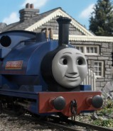](http://ttte.wikia.com/wiki/File:SirHandelpromo.jpg) [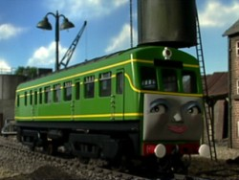](http://images.wikia.com/ttte/images/0/03/Daisy1.jpg) 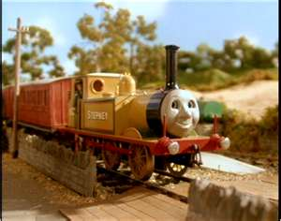



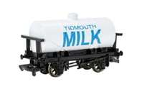Circle the car that is holding the most. Put an X on the car that is holding the least.   
1.

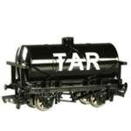

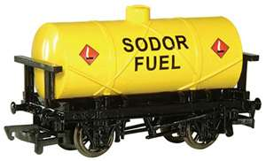2.

3.

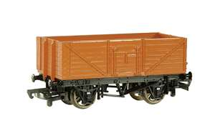

4. 

Count how many shapes each train is carrying. Tell what the shapes are.

_________________________________________________  
______________________________  
  
[](http://images.search.yahoo.com/r/_ylt=A0PDoS4MKzNPfGAAqYqjzbkF;_ylu=X3oDMTBpcGszamw0BHNlYwNmcC1pbWcEc2xrA2ltZw--/SIG=13lpkb4l7/EXP=1328782220/**http:/shop.nmj.no/product_info.php?manufacturers_id=40&amp;products_id=2094&amp;osCsid=411)____________________________

_______________

_________________________



Give the engines the coins they need for a ride. Cut and paste.

[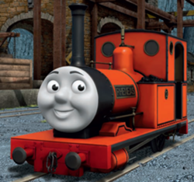](http://images.wikia.com/ttte/images/3/3b/RheneasCGIPromo.png)wants only pennies. ____________________

[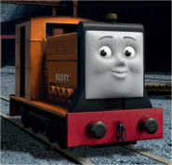](http://ttte.wikia.com/wiki/File:RustyCGIPromo.png) wants only nickels._____________________

[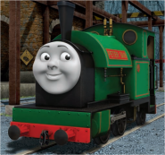](http://ttte.wikia.com/wiki/File:PeterSamCGIPromo.png) wants only dimes.______________________

[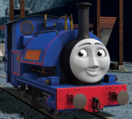](http://ttte.wikia.com/wiki/File:SirHandelCGIPromo.png) wants only quarters.___________________

[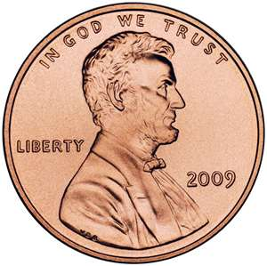](http://images.search.yahoo.com/images/view;_ylt=A0PDoS4kw5BP11oA8sCJzbkF;_ylu=X3oDMTBlMTQ4cGxyBHNlYwNzcgRzbGsDaW1n?back=http%3A%2F%2Fimages.search.yahoo.com%2Fsearch%2Fimages%3Fp%3Dpenny%26fr%3Dslv8-%26fr2%3Dpiv-web%26tab%3Dorganic%26ri%3D1&w=750&h=749&imgurl=newpenny.net%2Fwp-content%2Fuploads%2F2009%2F09%2FLincoln_Penny_Obverse.jpg&rurl=http%3A%2F%2Fnewpenny.net%2F&size=172.2+KB&name=New+Penny+Information%2C+Featuring+2009+Lincoln+Pennies+and+the+2010+...&p=penny&oid=d40583faae684907ebb296329a6f3089&fr2=piv-web&fr=slv8-&tt=New%2BPenny%2BInformation%252C%2BFeaturing%2B2009%2BLincoln%2BPennies%2Band%2Bthe%2B2010%2B...&b=0&ni=30&no=1&tab=organic&ts=&sigr=10kt1k4k5&sigb=12qmik14d&sigi=121p8vjeb&.crumb=hpgdZvBEC8P) [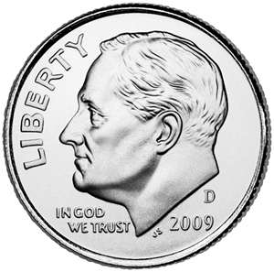](http://images.search.yahoo.com/images/view;_ylt=A0PDoYA6xJBP73YANSmJzbkF;_ylu=X3oDMTBlMTQ4cGxyBHNlYwNzcgRzbGsDaW1n?back=http%3A%2F%2Fimages.search.yahoo.com%2Fsearch%2Fimages%3Fp%3Ddime%26n%3D30%26ei%3Dutf-8%26y%3DSearch%26fr%3Dslv8-%26tab%3Dorganic%26ri%3D6&w=722&h=717&imgurl=www.knewmismatic.com%2Fsite_media%2Fmedia%2Fcoins%2F2010%2F03%2Froosevelt-dime-2009DimeObvUnc_jpg_1000x1000_q85.jpg&rurl=http%3A%2F%2Fwww.knewmismatic.com%2Fcoins%2F76-roosevelt-dime%2F&size=354.6+KB&name=Knewmismatic+%3A%3A+Coin+Dimes+-+Roosevelt+Dime&p=dime&oid=d6535e656998242e98cdc2473d7e2c7e&fr2=&fr=slv8-&tt=Knewmismatic%2B%253A%253A%2BCoin%2BDimes%2B-%2BRoosevelt%2BDime&b=0&ni=30&no=6&tab=organic&ts=&sigr=11ktlr51d&sigb=134p7fluu&sigi=13754a57j&.crumb=hpgdZvBEC8P) [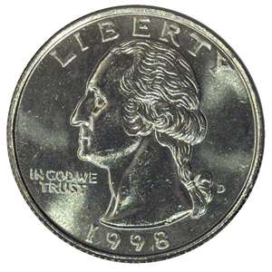](http://images.search.yahoo.com/images/view;_ylt=A0PDoTFpxJBPiQMA_ICJzbkF;_ylu=X3oDMTBlMTQ4cGxyBHNlYwNzcgRzbGsDaW1n?back=http%3A%2F%2Fimages.search.yahoo.com%2Fsearch%2Fimages%3Fp%3Dquarter%26n%3D30%26ei%3Dutf-8%26y%3DSearch%26fr%3Dslv8-%26tab%3Dorganic%26ri%3D4&w=970&h=970&imgurl=www.ngccoin.com%2Fimages%2Fcga%2FWashington-Quarters-Obverse.jpg&rurl=http%3A%2F%2Fwww.ngccoin.com%2Fcoin-grading-guide%2FGrading-Washington-Quarters.aspx&size=229.7+KB&name=...+Washington+Quarters+-+Washington+25C+-+Washington+Quarter+Dollar&p=quarter&oid=76e71401b1af7f0938fdc88ba2d3303a&fr2=&fr=slv8-&tt=...%2BWashington%2BQuarters%2B-%2BWashington%2B25C%2B-%2BWashington%2BQuarter%2BDollar&b=0&ni=30&no=4&tab=organic&ts=&sigr=12ails5au&sigb=1379n428t&sigi=11q9g3d2l&.crumb=hpgdZvBEC8P) [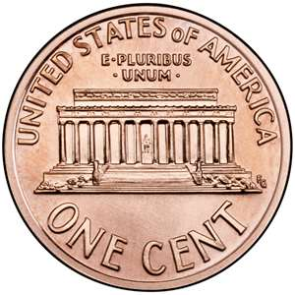](http://images.search.yahoo.com/images/view;_ylt=A0PDoYArxJBPvGsAdd6JzbkF;_ylu=X3oDMTBlMTQ4cGxyBHNlYwNzcgRzbGsDaW1n?back=http%3A%2F%2Fimages.search.yahoo.com%2Fsearch%2Fimages%3Fp%3Dpenny%2B-%2Btails%26n%3D30%26ei%3Dutf-8%26y%3DSearch%26fr%3Dslv8-%26tab%3Dorganic%26ri%3D0&w=756&h=756&imgurl=murchkindergarten2.files.wordpress.com%2F2010%2F09%2Ftails-penny.jpg&rurl=http%3A%2F%2Fmurchkindergarten2.wordpress.com%2F2010%2F09%2F&size=593.8+KB&name=penny+tails&p=penny+-+tails&oid=75eb808f3a1510f529dfc3e20fcfecf6&fr2=&fr=slv8-&tt=penny%2Btails&b=0&ni=30&no=0&tab=organic&ts=&sigr=11g96900e&sigb=13do440ca&sigi=11ussb58g&.crumb=hpgdZvBEC8P) [](http://images.search.yahoo.com/images/view;_ylt=A0PDoTFTxJBP_X0ArhKJzbkF;_ylu=X3oDMTBlMTQ4cGxyBHNlYwNzcgRzbGsDaW1n?back=http%3A%2F%2Fimages.search.yahoo.com%2Fsearch%2Fimages%3Fp%3Dnickel%26n%3D30%26ei%3Dutf-8%26y%3DSearch%26fr%3Dslv8-%26tab%3Dorganic%26ri%3D1&w=800&h=800&imgurl=www.valdosta.edu%2F%257Ecanwilliams%2Fnickel2.jpg&rurl=http%3A%2F%2Fwww.valdosta.edu%2F%257Ecanwilliams%2Febook3.html&size=415.4+KB&name=Nickel+is+a+silver+colored+coin+thatis+worth+5+cents.&p=nickel&oid=053b9a3f37348464f90e9503e7946365&fr2=&fr=slv8-&tt=Nickel%2Bis%2Ba%2Bsilver%2Bcolored%2Bcoin%2Bthatis%2Bworth%2B5%2Bcents.&b=0&ni=30&no=1&tab=organic&ts=&sigr=11ijvg7nv&sigb=136f7jmnm&sigi=11bh9amug&.crumb=hpgdZvBEC8P) [](http://images.search.yahoo.com/images/view;_ylt=A0PDoYA6xJBP73YANSmJzbkF;_ylu=X3oDMTBlMTQ4cGxyBHNlYwNzcgRzbGsDaW1n?back=http%3A%2F%2Fimages.search.yahoo.com%2Fsearch%2Fimages%3Fp%3Ddime%26n%3D30%26ei%3Dutf-8%26y%3DSearch%26fr%3Dslv8-%26tab%3Dorganic%26ri%3D6&w=722&h=717&imgurl=www.knewmismatic.com%2Fsite_media%2Fmedia%2Fcoins%2F2010%2F03%2Froosevelt-dime-2009DimeObvUnc_jpg_1000x1000_q85.jpg&rurl=http%3A%2F%2Fwww.knewmismatic.com%2Fcoins%2F76-roosevelt-dime%2F&size=354.6+KB&name=Knewmismatic+%3A%3A+Coin+Dimes+-+Roosevelt+Dime&p=dime&oid=d6535e656998242e98cdc2473d7e2c7e&fr2=&fr=slv8-&tt=Knewmismatic%2B%253A%253A%2BCoin%2BDimes%2B-%2BRoosevelt%2BDime&b=0&ni=30&no=6&tab=organic&ts=&sigr=11ktlr51d&sigb=134p7fluu&sigi=13754a57j&.crumb=hpgdZvBEC8P) [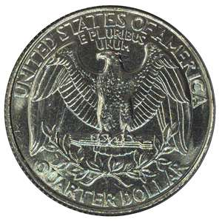](http://images.search.yahoo.com/images/view;_ylt=A0PDoTFpxJBPiQMAAIGJzbkF;_ylu=X3oDMTBlMTQ4cGxyBHNlYwNzcgRzbGsDaW1n?back=http%3A%2F%2Fimages.search.yahoo.com%2Fsearch%2Fimages%3Fp%3Dquarter%26n%3D30%26ei%3Dutf-8%26y%3DSearch%26fr%3Dslv8-%26tab%3Dorganic%26ri%3D8&w=970&h=970&imgurl=www.ngccoin.com%2Fimages%2Fcga%2FWashington-Quarters-Reverse.jpg&rurl=http%3A%2F%2Fwww.ngccoin.com%2Fcoin-grading-guide%2FGrading-Washington-Quarters.aspx&size=276+KB&name=...+Washington+Quarters+-+Washington+25C+-+Washington+Quarter+Dollar&p=quarter&oid=d8f6e4281777da331449729df3713fd5&fr2=&fr=slv8-&tt=...%2BWashington%2BQuarters%2B-%2BWashington%2B25C%2B-%2BWashington%2BQuarter%2BDollar&b=0&ni=30&no=8&tab=organic&ts=&sigr=12ails5au&sigb=1375n1n21&sigi=11qhbefgq&.crumb=hpgdZvBEC8P) [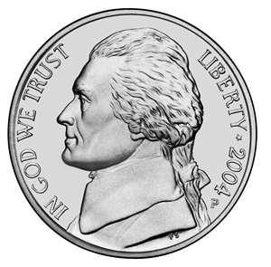](http://images.search.yahoo.com/images/view;_ylt=A0PDoTFTxJBP_X0ArRKJzbkF;_ylu=X3oDMTBlMTQ4cGxyBHNlYwNzcgRzbGsDaW1n?back=http%3A%2F%2Fimages.search.yahoo.com%2Fsearch%2Fimages%3Fp%3Dnickel%26n%3D30%26ei%3Dutf-8%26y%3DSearch%26fr%3Dslv8-%26tab%3Dorganic%26ri%3D0&w=1523&h=1500&imgurl=upload.wikimedia.org%2Fwikipedia%2Fcommons%2F7%2F72%2FJefferson-Nickel-Unc-Obv.jpg&rurl=http%3A%2F%2Fen.wikipedia.org%2Fwiki%2FFile%3AJefferson-Nickel-Unc-Obv.jpg&size=492.9+KB&name=File%3AJefferson-Nickel-Unc-Obv.jpg+-+Wikipedia%2C+the+free+encyclopedia&p=nickel&oid=b59966ee0deb08d7f3c38a82e8364656&fr2=&fr=slv8-&tt=File%253AJefferson-Nickel-Unc-Obv.jpg%2B-%2BWikipedia%252C%2Bthe%2Bfree%2Bencyclopedia&b=0&ni=30&no=0&tab=organic&ts=&sigr=11uigp5fe&sigb=136l0o26p&sigi=128v8o5d2&.crumb=hpgdZvBEC8P)[](http://images.search.yahoo.com/images/view;_ylt=A0PDoS4kw5BP11oA8sCJzbkF;_ylu=X3oDMTBlMTQ4cGxyBHNlYwNzcgRzbGsDaW1n?back=http%3A%2F%2Fimages.search.yahoo.com%2Fsearch%2Fimages%3Fp%3Dpenny%26fr%3Dslv8-%26fr2%3Dpiv-web%26tab%3Dorganic%26ri%3D1&w=750&h=749&imgurl=newpenny.net%2Fwp-content%2Fuploads%2F2009%2F09%2FLincoln_Penny_Obverse.jpg&rurl=http%3A%2F%2Fnewpenny.net%2F&size=172.2+KB&name=New+Penny+Information%2C+Featuring+2009+Lincoln+Pennies+and+the+2010+...&p=penny&oid=d40583faae684907ebb296329a6f3089&fr2=piv-web&fr=slv8-&tt=New%2BPenny%2BInformation%252C%2BFeaturing%2B2009%2BLincoln%2BPennies%2Band%2Bthe%2B2010%2B...&b=0&ni=30&no=1&tab=organic&ts=&sigr=10kt1k4k5&sigb=12qmik14d&sigi=121p8vjeb&.crumb=hpgdZvBEC8P) [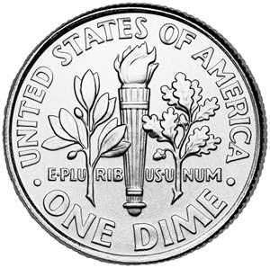](http://images.search.yahoo.com/images/view;_ylt=A0PDoYA6xJBP73YAMymJzbkF;_ylu=X3oDMTBlMTQ4cGxyBHNlYwNzcgRzbGsDaW1n?back=http%3A%2F%2Fimages.search.yahoo.com%2Fsearch%2Fimages%3Fp%3Ddime%26n%3D30%26ei%3Dutf-8%26y%3DSearch%26fr%3Dslv8-%26tab%3Dorganic%26ri%3D4&w=720&h=716&imgurl=coinpix.com%2Fwp-content%2Fuploads%2F2010%2F05%2FRoosevelt-Dime-Reverse.jpg&rurl=http%3A%2F%2Fcoinpix.com%2Froosevelt-dime-reverse%2F&size=131.7+KB&name=Roosevelt+Dime+Reverse+%7C+Coin+Pix&p=dime&oid=0c40951a9a8d63222db120d238d29a2f&fr2=&fr=slv8-&tt=Roosevelt%2BDime%2BReverse%2B%257C%2BCoin%2BPix&b=0&ni=30&no=4&tab=organic&ts=&sigr=11a765bhg&sigb=134oqpl8k&sigi=1211u48id&.crumb=hpgdZvBEC8P) [](http://images.search.yahoo.com/images/view;_ylt=A0PDoTFTxJBP_X0ArhKJzbkF;_ylu=X3oDMTBlMTQ4cGxyBHNlYwNzcgRzbGsDaW1n?back=http%3A%2F%2Fimages.search.yahoo.com%2Fsearch%2Fimages%3Fp%3Dnickel%26n%3D30%26ei%3Dutf-8%26y%3DSearch%26fr%3Dslv8-%26tab%3Dorganic%26ri%3D1&w=800&h=800&imgurl=www.valdosta.edu%2F%257Ecanwilliams%2Fnickel2.jpg&rurl=http%3A%2F%2Fwww.valdosta.edu%2F%257Ecanwilliams%2Febook3.html&size=415.4+KB&name=Nickel+is+a+silver+colored+coin+thatis+worth+5+cents.&p=nickel&oid=053b9a3f37348464f90e9503e7946365&fr2=&fr=slv8-&tt=Nickel%2Bis%2Ba%2Bsilver%2Bcolored%2Bcoin%2Bthatis%2Bworth%2B5%2Bcents.&b=0&ni=30&no=1&tab=organic&ts=&sigr=11ijvg7nv&sigb=136f7jmnm&sigi=11bh9amug&.crumb=hpgdZvBEC8P) [](http://images.search.yahoo.com/images/view;_ylt=A0PDoTFpxJBPiQMAAIGJzbkF;_ylu=X3oDMTBlMTQ4cGxyBHNlYwNzcgRzbGsDaW1n?back=http%3A%2F%2Fimages.search.yahoo.com%2Fsearch%2Fimages%3Fp%3Dquarter%26n%3D30%26ei%3Dutf-8%26y%3DSearch%26fr%3Dslv8-%26tab%3Dorganic%26ri%3D8&w=970&h=970&imgurl=www.ngccoin.com%2Fimages%2Fcga%2FWashington-Quarters-Reverse.jpg&rurl=http%3A%2F%2Fwww.ngccoin.com%2Fcoin-grading-guide%2FGrading-Washington-Quarters.aspx&size=276+KB&name=...+Washington+Quarters+-+Washington+25C+-+Washington+Quarter+Dollar&p=quarter&oid=d8f6e4281777da331449729df3713fd5&fr2=&fr=slv8-&tt=...%2BWashington%2BQuarters%2B-%2BWashington%2B25C%2B-%2BWashington%2BQuarter%2BDollar&b=0&ni=30&no=8&tab=organic&ts=&sigr=12ails5au&sigb=1375n1n21&sigi=11qhbefgq&.crumb=hpgdZvBEC8P) [](http://images.search.yahoo.com/images/view;_ylt=A0PDoYArxJBPvGsAdd6JzbkF;_ylu=X3oDMTBlMTQ4cGxyBHNlYwNzcgRzbGsDaW1n?back=http%3A%2F%2Fimages.search.yahoo.com%2Fsearch%2Fimages%3Fp%3Dpenny%2B-%2Btails%26n%3D30%26ei%3Dutf-8%26y%3DSearch%26fr%3Dslv8-%26tab%3Dorganic%26ri%3D0&w=756&h=756&imgurl=murchkindergarten2.files.wordpress.com%2F2010%2F09%2Ftails-penny.jpg&rurl=http%3A%2F%2Fmurchkindergarten2.wordpress.com%2F2010%2F09%2F&size=593.8+KB&name=penny+tails&p=penny+-+tails&oid=75eb808f3a1510f529dfc3e20fcfecf6&fr2=&fr=slv8-&tt=penny%2Btails&b=0&ni=30&no=0&tab=organic&ts=&sigr=11g96900e&sigb=13do440ca&sigi=11ussb58g&.crumb=hpgdZvBEC8P) [](http://images.search.yahoo.com/images/view;_ylt=A0PDoTFpxJBPiQMA_ICJzbkF;_ylu=X3oDMTBlMTQ4cGxyBHNlYwNzcgRzbGsDaW1n?back=http%3A%2F%2Fimages.search.yahoo.com%2Fsearch%2Fimages%3Fp%3Dquarter%26n%3D30%26ei%3Dutf-8%26y%3DSearch%26fr%3Dslv8-%26tab%3Dorganic%26ri%3D4&w=970&h=970&imgurl=www.ngccoin.com%2Fimages%2Fcga%2FWashington-Quarters-Obverse.jpg&rurl=http%3A%2F%2Fwww.ngccoin.com%2Fcoin-grading-guide%2FGrading-Washington-Quarters.aspx&size=229.7+KB&name=...+Washington+Quarters+-+Washington+25C+-+Washington+Quarter+Dollar&p=quarter&oid=76e71401b1af7f0938fdc88ba2d3303a&fr2=&fr=slv8-&tt=...%2BWashington%2BQuarters%2B-%2BWashington%2B25C%2B-%2BWashington%2BQuarter%2BDollar&b=0&ni=30&no=4&tab=organic&ts=&sigr=12ails5au&sigb=1379n428t&sigi=11q9g3d2l&.crumb=hpgdZvBEC8P) [](http://images.search.yahoo.com/images/view;_ylt=A0PDoTFTxJBP_X0ArRKJzbkF;_ylu=X3oDMTBlMTQ4cGxyBHNlYwNzcgRzbGsDaW1n?back=http%3A%2F%2Fimages.search.yahoo.com%2Fsearch%2Fimages%3Fp%3Dnickel%26n%3D30%26ei%3Dutf-8%26y%3DSearch%26fr%3Dslv8-%26tab%3Dorganic%26ri%3D0&w=1523&h=1500&imgurl=upload.wikimedia.org%2Fwikipedia%2Fcommons%2F7%2F72%2FJefferson-Nickel-Unc-Obv.jpg&rurl=http%3A%2F%2Fen.wikipedia.org%2Fwiki%2FFile%3AJefferson-Nickel-Unc-Obv.jpg&size=492.9+KB&name=File%3AJefferson-Nickel-Unc-Obv.jpg+-+Wikipedia%2C+the+free+encyclopedia&p=nickel&oid=b59966ee0deb08d7f3c38a82e8364656&fr2=&fr=slv8-&tt=File%253AJefferson-Nickel-Unc-Obv.jpg%2B-%2BWikipedia%252C%2Bthe%2Bfree%2Bencyclopedia&b=0&ni=30&no=0&tab=organic&ts=&sigr=11uigp5fe&sigb=136l0o26p&sigi=128v8o5d2&.crumb=hpgdZvBEC8P) [](http://images.search.yahoo.com/images/view;_ylt=A0PDoYA6xJBP73YAMymJzbkF;_ylu=X3oDMTBlMTQ4cGxyBHNlYwNzcgRzbGsDaW1n?back=http%3A%2F%2Fimages.search.yahoo.com%2Fsearch%2Fimages%3Fp%3Ddime%26n%3D30%26ei%3Dutf-8%26y%3DSearch%26fr%3Dslv8-%26tab%3Dorganic%26ri%3D4&w=720&h=716&imgurl=coinpix.com%2Fwp-content%2Fuploads%2F2010%2F05%2FRoosevelt-Dime-Reverse.jpg&rurl=http%3A%2F%2Fcoinpix.com%2Froosevelt-dime-reverse%2F&size=131.7+KB&name=Roosevelt+Dime+Reverse+%7C+Coin+Pix&p=dime&oid=0c40951a9a8d63222db120d238d29a2f&fr2=&fr=slv8-&tt=Roosevelt%2BDime%2BReverse%2B%257C%2BCoin%2BPix&b=0&ni=30&no=4&tab=organic&ts=&sigr=11a765bhg&sigb=134oqpl8k&sigi=1211u48id&.crumb=hpgdZvBEC8P)

Use flatbed cars to show money and have Thomas explain each coin.

Then use toy trains with a price tag next to them to buy with the coins given.

Also have a cut and paste game with coins…Help the little trains gather up the money that has their number or the coins they want. Rheneas and pennies. Rusty with nickels. Duke with dimes. ?-quarters. Thomas with dollars.

Match the heads with the tails on flatbeds.

Count the money that each engine is carrying.

Name the shapes and count each shape that engines is carrying. Henry Circle 5, James Triangles 2, Gordon squares 7, Percy ovals 4, Duck hearts 1, extra: Harold stars 3,

Have a cut and paste paper with numbers 1-10 one-ten.  
Train – one cut and paste 1.  
Train – seven cut and paste 7. Etc

Have engines each pulling a load and ask Gio which car is holding the most water, coal, people, milk, etc. Use different size cars.

[](http://images.search.yahoo.com/images/view;_ylt=A0PDoTC5QS9PNCAAp1CJzbkF;_ylu=X3oDMTA3cnMybzJvBHNsawNpbWc-?back=http://images.search.yahoo.com/search/images?p=thomas+and+friends+milk+car&n=30&ei=utf-8&y=Search&tab=organic&ri=0&w=300&h=184&imgurl=www.pamodelrrsupply.com/media/00/a20791512bec1744f61298_m.JPG&rurl=http://www.pamodelrrsupply.com/servlet/the-523/thomas-ho-oo-milk/Detail&size=17.4+KB&name=HO+Tidmouth+Milk+Tank+car+Thomas+&amp;+Friends+Bachmann&p=thomas+and+friends+milk+car&oid=25f732100ab6edf5a71f95caef4ad336&fr2=&fr=&tt=HO+Tidmouth+Milk+Tank+car+Thomas+&amp;+Friends+Bachmann&b=0&ni=32&no=0&tab=organic&ts=&sigr=127cgv3l0&sigb=13itbmto7&sigi=11tttb673&.crumb=RfDs76VF5T1) [](http://images.search.yahoo.com/images/view;_ylt=A0PDoTC5QS9PNCAAp1CJzbkF;_ylu=X3oDMTA3cnMybzJvBHNsawNpbWc-?back=http://images.search.yahoo.com/search/images?p=thomas+and+friends+milk+car&n=30&ei=utf-8&y=Search&tab=organic&ri=0&w=300&h=184&imgurl=www.pamodelrrsupply.com/media/00/a20791512bec1744f61298_m.JPG&rurl=http://www.pamodelrrsupply.com/servlet/the-523/thomas-ho-oo-milk/Detail&size=17.4+KB&name=HO+Tidmouth+Milk+Tank+car+Thomas+&amp;+Friends+Bachmann&p=thomas+and+friends+milk+car&oid=25f732100ab6edf5a71f95caef4ad336&fr2=&fr=&tt=HO+Tidmouth+Milk+Tank+car+Thomas+&amp;+Friends+Bachmann&b=0&ni=32&no=0&tab=organic&ts=&sigr=127cgv3l0&sigb=13itbmto7&sigi=11tttb673&.crumb=RfDs76VF5T1)   [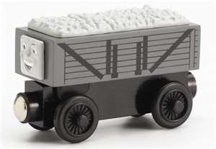](http://images.search.yahoo.com/images/view;_ylt=A0PDoS8hOjNPLgsAANiJzbkF;_ylu=X3oDMTBlMTQ4cGxyBHNlYwNzcgRzbGsDaW1n?back=http://images.search.yahoo.com/search/images?p=coal+car+thomas+and+friends&n=30&ei=utf-8&y=Search+Images&tab=organic&ri=280&w=575&h=397&imgurl=www.tootinthomastrains.co.uk/ekmps/shops/tootinthomast/images/thomas-and-friends-wooden-railway-giggling-troublesome-trucks-%5b2%5d-513-p.jpg&rurl=http://www.tootinthomastrains.co.uk/thomas-and-friends-wooden-railway---giggling-troublesome-trucks-513-p.asp&size=39.3+KB&name=Thomas+and+Friends+Wooden+Railway+-+Giggling+Troublesome+Trucks+...&p=coal+car+thomas+and+friends&oid=97a293f35f7477527bbea92cc59bf265&fr2=&fr=&tt=Thomas+and+Friends+Wooden+Railway+-+Giggling+Troublesome+Trucks+...&b=271&ni=96&no=280&tab=organic&ts=&sigr=13ddq9cvl&sigb=13r4o5gmt&sigi=1499a9n04&.crumb=U.CAUwVdo0G) [](http://images.search.yahoo.com/images/view;_ylt=A0PDoS8hOjNPLgsAANiJzbkF;_ylu=X3oDMTBlMTQ4cGxyBHNlYwNzcgRzbGsDaW1n?back=http://images.search.yahoo.com/search/images?p=coal+car+thomas+and+friends&n=30&ei=utf-8&y=Search+Images&tab=organic&ri=280&w=575&h=397&imgurl=www.tootinthomastrains.co.uk/ekmps/shops/tootinthomast/images/thomas-and-friends-wooden-railway-giggling-troublesome-trucks-%5b2%5d-513-p.jpg&rurl=http://www.tootinthomastrains.co.uk/thomas-and-friends-wooden-railway---giggling-troublesome-trucks-513-p.asp&size=39.3+KB&name=Thomas+and+Friends+Wooden+Railway+-+Giggling+Troublesome+Trucks+...&p=coal+car+thomas+and+friends&oid=97a293f35f7477527bbea92cc59bf265&fr2=&fr=&tt=Thomas+and+Friends+Wooden+Railway+-+Giggling+Troublesome+Trucks+...&b=271&ni=96&no=280&tab=organic&ts=&sigr=13ddq9cvl&sigb=13r4o5gmt&sigi=1499a9n04&.crumb=U.CAUwVdo0G)

[](http://images.search.yahoo.com/images/view;_ylt=A0PDoS.xOjNPJUcAf2eJzbkF;_ylu=X3oDMTBlMTQ4cGxyBHNlYwNzcgRzbGsDaW1n?back=http://images.search.yahoo.com/search/images?p=tar+car+thomas+and+friends&n=30&ei=utf-8&y=Search&tab=organic&ri=29&w=150&h=150&imgurl=www.trainz.com/images/Product/icon/180237.jpg&rurl=http://www.trainz.com/c-395-ho-scale-electric-trains.aspx?pagenum=3&size=8.3+KB&name=Bachmann+77049+HO+Thomas+&amp;+Friends+Tar+Tank&p=tar+car+thomas+and+friends&oid=f5eb995dbf85b44ae734ff6bfd196361&fr2=&fr=&tt=Bachmann+77049+HO+Thomas+%26amp%3B+Friends+Tar+Tank&b=0&ni=96&no=29&tab=organic&ts=&sigr=1230p9q68&sigb=13i85mg6d&sigi=11d1oq864&.crumb=U.CAUwVdo0G) [](http://images.search.yahoo.com/images/view;_ylt=A0PDoS.xOjNPJUcAf2eJzbkF;_ylu=X3oDMTBlMTQ4cGxyBHNlYwNzcgRzbGsDaW1n?back=http://images.search.yahoo.com/search/images?p=tar+car+thomas+and+friends&n=30&ei=utf-8&y=Search&tab=organic&ri=29&w=150&h=150&imgurl=www.trainz.com/images/Product/icon/180237.jpg&rurl=http://www.trainz.com/c-395-ho-scale-electric-trains.aspx?pagenum=3&size=8.3+KB&name=Bachmann+77049+HO+Thomas+&amp;+Friends+Tar+Tank&p=tar+car+thomas+and+friends&oid=f5eb995dbf85b44ae734ff6bfd196361&fr2=&fr=&tt=Bachmann+77049+HO+Thomas+%26amp%3B+Friends+Tar+Tank&b=0&ni=96&no=29&tab=organic&ts=&sigr=1230p9q68&sigb=13i85mg6d&sigi=11d1oq864&.crumb=U.CAUwVdo0G) [](http://images.search.yahoo.com/images/view;_ylt=A0PDoS.xOjNPJUcAf2eJzbkF;_ylu=X3oDMTBlMTQ4cGxyBHNlYwNzcgRzbGsDaW1n?back=http://images.search.yahoo.com/search/images?p=tar+car+thomas+and+friends&n=30&ei=utf-8&y=Search&tab=organic&ri=29&w=150&h=150&imgurl=www.trainz.com/images/Product/icon/180237.jpg&rurl=http://www.trainz.com/c-395-ho-scale-electric-trains.aspx?pagenum=3&size=8.3+KB&name=Bachmann+77049+HO+Thomas+&amp;+Friends+Tar+Tank&p=tar+car+thomas+and+friends&oid=f5eb995dbf85b44ae734ff6bfd196361&fr2=&fr=&tt=Bachmann+77049+HO+Thomas+%26amp%3B+Friends+Tar+Tank&b=0&ni=96&no=29&tab=organic&ts=&sigr=1230p9q68&sigb=13i85mg6d&sigi=11d1oq864&.crumb=U.CAUwVdo0G)

[](http://images.search.yahoo.com/images/view;_ylt=A0PDoS_OOjNPDGQAtJiJzbkF;_ylu=X3oDMTBlMTQ4cGxyBHNlYwNzcgRzbGsDaW1n?back=http://images.search.yahoo.com/search/images?p=sodor+fuel+thomas+and+friends&n=30&ei=utf-8&y=Search&tab=organic&ri=4&w=700&h=426&imgurl=pics.towerhobbies.com/imagel/b/lbacu6054.jpg&rurl=http://www3.towerhobbies.com/cgi-bin/wti0001p?&amp;I=LXJGG1&size=31.1+KB&name=TowerHobbies.com+|+77039+Bachmann+Sodor+Fuel+Tank+Thomas+&amp;+Friends+HO&p=sodor+fuel+thomas+and+friends&oid=bb4f77cc5b943bd133c296273f880c8a&fr2=&fr=&tt=TowerHobbies.com+%7C+77039+Bachmann+Sodor+Fuel+Tank+Thomas+%26amp%3B+Friends+HO&b=0&ni=96&no=4&tab=organic&ts=&sigr=11rlh5c8q&sigb=13ka4jb22&sigi=11cbbeg9q&.crumb=U.CAUwVdo0G) [](http://images.search.yahoo.com/images/view;_ylt=A0PDoS_OOjNPDGQAtJiJzbkF;_ylu=X3oDMTBlMTQ4cGxyBHNlYwNzcgRzbGsDaW1n?back=http://images.search.yahoo.com/search/images?p=sodor+fuel+thomas+and+friends&n=30&ei=utf-8&y=Search&tab=organic&ri=4&w=700&h=426&imgurl=pics.towerhobbies.com/imagel/b/lbacu6054.jpg&rurl=http://www3.towerhobbies.com/cgi-bin/wti0001p?&amp;I=LXJGG1&size=31.1+KB&name=TowerHobbies.com+|+77039+Bachmann+Sodor+Fuel+Tank+Thomas+&amp;+Friends+HO&p=sodor+fuel+thomas+and+friends&oid=bb4f77cc5b943bd133c296273f880c8a&fr2=&fr=&tt=TowerHobbies.com+%7C+77039+Bachmann+Sodor+Fuel+Tank+Thomas+%26amp%3B+Friends+HO&b=0&ni=96&no=4&tab=organic&ts=&sigr=11rlh5c8q&sigb=13ka4jb22&sigi=11cbbeg9q&.crumb=U.CAUwVdo0G) [](http://images.search.yahoo.com/images/view;_ylt=A0PDoS_OOjNPDGQAtJiJzbkF;_ylu=X3oDMTBlMTQ4cGxyBHNlYwNzcgRzbGsDaW1n?back=http://images.search.yahoo.com/search/images?p=sodor+fuel+thomas+and+friends&n=30&ei=utf-8&y=Search&tab=organic&ri=4&w=700&h=426&imgurl=pics.towerhobbies.com/imagel/b/lbacu6054.jpg&rurl=http://www3.towerhobbies.com/cgi-bin/wti0001p?&amp;I=LXJGG1&size=31.1+KB&name=TowerHobbies.com+|+77039+Bachmann+Sodor+Fuel+Tank+Thomas+&amp;+Friends+HO&p=sodor+fuel+thomas+and+friends&oid=bb4f77cc5b943bd133c296273f880c8a&fr2=&fr=&tt=TowerHobbies.com+%7C+77039+Bachmann+Sodor+Fuel+Tank+Thomas+%26amp%3B+Friends+HO&b=0&ni=96&no=4&tab=organic&ts=&sigr=11rlh5c8q&sigb=13ka4jb22&sigi=11cbbeg9q&.crumb=U.CAUwVdo0G)

